CTM-I Use Case

Wire Delete

Version 0.1

Use Case Name | Wire Delete
Actor | Market Operations, Operations, App Support
Pre-conditions /Assumptions | User has Browser and is aware of the http path to the application.  User has successfully logged into the CTM-I application.  User has the right role to see the menu options.
Post Conditions | None
Screenshot | 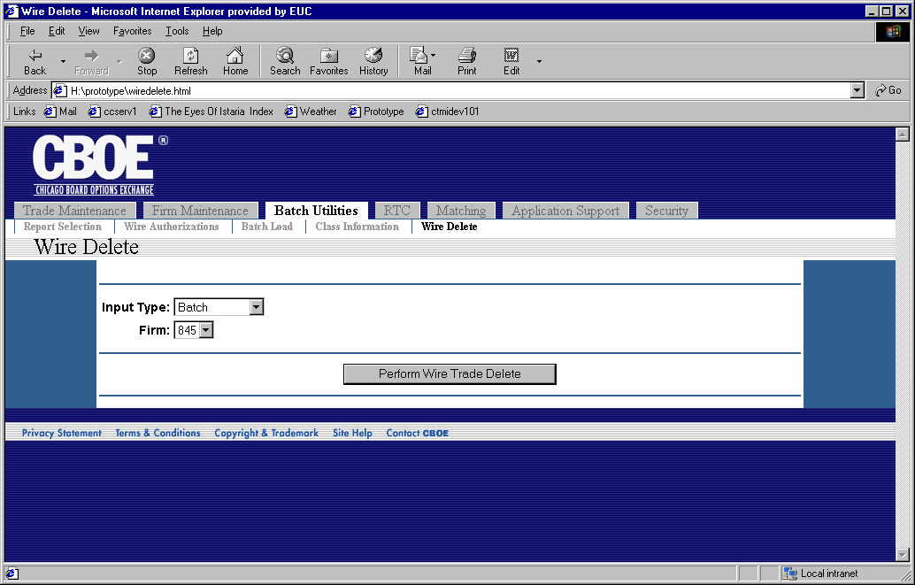
Flow of Events | - User selects “Wire Delete” from the menu.  - The Wire Delete screen is displayed.  - The user selects and input type and firm for the wire delete.  - The user presses the button “Perform Wire Trade Delete” to process the delete.  - The delete request is sent to CTM-R to process.  - The results of the CTM-R processing are displayed on the screen
Alternative Path | None

